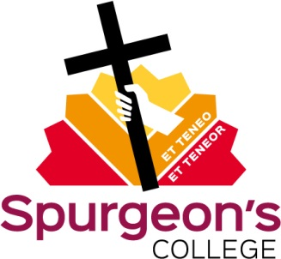

Terms of Reference for the Training Group

- The Training Group is an informal meeting which aims to facilitate the training and formation of the College’s students, especially of those training for church ministry.

- The normal participants in these meetings are:
  - The Vice Principal (Director of Training) (convenor)
  - The Director of Practical Training
  - The Vice Principal (Director of Studies)The Senior Registrar The Principal and any pastoral tutors are involved as necessary.

- The focus of the Group is on individual students who need special attention, not on structures.

- The group discusses issues including, but not limited to, students’ placements, progress (or lack thereof), programmes, changes of pathway, conversion interviews, withdrawals, deferrals, and any issues within pastoral groups.

Document control box
Title | Terms of Reference for the Training Group
Date approved | June 2016 | Implementation date | November 2013
Next review date
Version | 2 | Supersedes version | 1 (Nov 2013)
Approving body |  | Leadership Team
Quality Code consulted |  | TBC
Member of staff responsible |  | Director of Training

